Explanation 1
This paper introduces Conformal Score Aggregation (CSA), a framework designed to provide high-quality uncertainty estimates for ensemble models without relying on rigid distributional assumptions.
The core innovation is that instead of combining the final "prediction regions" of different models (which is often inefficient and conservative), CSA combines their underlying scores in a multi-dimensional space to create much tighter, more informative uncertainty regions.

1. The Core Problem: Inefficiency in Ensembles
When you have an ensemble of K models, the goal is to produce a prediction region $C\left(x\right)$ that contains the true value $Y$ with a guaranteed probability (e.g., $1-α$).
- Naive Approach: Conformalize the average prediction. This often ignores that some models are much more certain than others in specific parts of the data space.
- Existing Aggregation: Most methods (like Majority Vote) merge the individual prediction sets of each model. This is "conservative," meaning the resulting sets are often unnecessarily large.
2. The CSA Framework: Score-Based Aggregation
CSA moves the aggregation step from the "output space" to the "score space".
A. Multivariate Scores
Instead of a single scalar score, CSA defines a multivariate score vector $s\left(x,y\right):={(s}_{1}\left(x,y\right),..., s_{K}\left(x,y\right))$where each component represents the error/conformity score of one model in the ensemble.
B. Quantile Envelopes
To define an "ordering" in this multi-dimensional space (which has no natural order), CSA uses Quantile Envelopes.
- It projects the multidimensional scores along various directions {$u_{m}$}.
- It finds the intersection of the resulting half-planes to form a convex acceptance region $\hat{Q}$.
- Geometric Intuition: Think of it as finding the tightest convex "hull" that contains a specific percentage ($1-α$) of the calibration score points.

C. Two-Stage Calibration
To maintain mathematical rigor and coverage guarantees, the calibration set $D_{C}$is split into two parts:
- $Dc^{\left(1\right)}:$ Used to determine the shape (the directions and relative weights) of the quantile envelope.
- $Dc^{\left(2\right)}:$ Used to determine the final scale (threshold $\hat{t}$) of the envelope to ensure exactly $1-α$ coverage on unseen data.

3. Mathematical Rigor: Theorem 3.1
The authors prove that if the calibration data and test data are exchangeable, the CSA region $C\left(x\right)$ provides a formal frequentist coverage guarantee:
$$P_{X^{'},Y^{'}}\left(Y^{'}∈C\left(X^{'}\right)\right)≥1-α$$
This holds regardless of the underlying distribution of the data or the complexity of the black-box models in the ensemble.

4. Key Application: Predict-Then-Optimize
This is particularly relevant for your work in computational biology, where predictions are often inputs for further decisions (e.g., resource allocation or experimental design).
In a robust setting, instead of optimizing for one point prediction, you optimize for the worst-case scenario within the prediction region:
$$w^{*}\left(x\right)≔\min_{w}\max_{c∈C^{\left(x\right)}}f\left(w,c\right)$$
The authors demonstrate that because CSA produces convex acceptance regions, this "inner maximization" problem remains a standard convex optimization problem, making it computationally tractable even in high dimensions.

5. Empirical Results
- Efficiency: On ImageNet, CSA produced prediction sets significantly smaller (more precise) than any other aggregation method while maintaining the $1-α$ coverage.
- Robustness: Even if some models in the ensemble are "bad" or redundant, CSA effectively learns to ignore them or adapt to the most certain model, nearly matching the performance of the single best model.
- Computation: The method is highly efficient because the score computations can be vectorized, scaling gracefully with the number of models (K) and projection directions (M).

Summary Table: CSA vs. Competitors
Feature | Naive Conformal | Region Aggregation | CSA (This Paper)
Input | Average prediction | Individual regions | Multivariate scores
Space | Output space | Output space | Score space
Precision | Low | Moderate | High (Minimal size)
Flexibility | Limited | Classification only | Class. & Regression

Would you like me to draft a summary of how this specific "score space" approach could be applied to a typical computational biology ensemble, like protein structure or gene expression predictors?

Explanation 2
discuss the specific geometric construction, the data-splitting mechanics, and the "Predict-Then-Optimize" (PTO) extension.
1. The Mathematical Motivation (The "Why")
The paper argues that existing conformal aggregation methods (like Majority Vote) are "conservative" because they operate on prediction regions $C_{k}\left(x\right)$. When you merge sets, you lose the underlying "shared structure" or correlation between the models' errors.
CSA's core thesis is that by treating scores as a multivariate vector $s\left(x,y\right)∈R^{K}$, you can find a more efficient acceptance region $\hat{Q}$in score space. A tighter $\hat{Q}$directly translates to a smaller, more informative prediction region in the output space $Y$.

2. The CSA Algorithm
The paper introduces a two-stage calibration process to ensure distribution-free coverage while optimizing for the "tightest" possible fit.
Phase I: Defining the Pre-Ordering (on $S_{C}^{\left(1\right)}$ )
Because there is no natural ordering for multivariate data, the authors use directional quantiles and quantile envelopes.
- Directional Projection: They sample $M$directions {$u_{m}$} uniformly from the unit hypersphere $S_{+}^{K-1}$.
- Half-Plane Construction: For each direction $u_{m}$, they define a half-plane $H\left(u_{m},q_{m}\right)=\left\{x:u_{m}^{T}x≤q_{m}\right\}$ .
- The -Search: They don't just use $1-α$ for each direction (which would be too small). They perform a binary search to find a parameter $β^{*}$ such that the intersection of all $M$ half-planes covers exactly $1-α$ of the calibration points in $S_{C}^{\left(1\right)}$.
- The Acceptance Region: This yields a convex set . 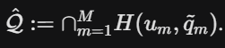

Phase II: Scaling and Final Calibration (on $S_{C}^{\left(2\right)}$)

To guarantee coverage on unseen data without "overfitting" the shape of the envelope, they use the second split.

1.
**The Adjustment Factor **: They calculate how much the envelope must be scaled (expanded or contracted) to cover the quantile of the points in .

2.
**Final Thresholds**: The final calibrated thresholds are .

---

## 3. Theorem 3.1: The Coverage Guarantee

You can confidently tell your professor that CSA retains the **marginal frequentist coverage guarantee**.

*
**The Proof**: The authors prove this by replacing the standard scalar ordering with a **pre-ordering** induced by the nested sets .

*
**Exchangeability**: As long as the calibration and test scores are exchangeable, the probability that a new test point's score falls outside the acceptance region is .

---

## 4. Application: Predict-Then-Optimize (PTO)

This is the most technically complex part of the paper (Section 3.2). In many high-stakes fields, we don't just want a prediction; we want to make a **robust decision**.

The paper focuses on the **GPCP score**:

Where each predictor provides samples (generative models).

**Why it’s impressive:**

*
**Convexity**: Because the acceptance region is the intersection of half-planes (convex), the robust optimization problem—finding the worst-case parameter within the region—remains a **standard convex optimization problem**.

*
**Tractability**: Even though the feasible region is the union of several convex sets (one for each combination of samples from the ensemble), the problem can be parallelized across the indexing tuple .

---

## 5. Experimental Evidence to Cite

If your professor asks about performance, mention these specific takeaways:

*
**ImageNet**: CSA consistently produced set sizes significantly smaller than individual models and "Naive" ensembles.

*
**Regression (OpenML)**: The authors used an "ablation" (Single-Stage calibration) to prove that splitting into two parts is essential; without it, the model fails to maintain coverage.

*
**Degenerate Cases (UCI)**: In cases where one model (like Random Forest) is significantly better than others, CSA is robust enough to nearly match that best model's performance rather than being dragged down by the weaker ones.

*
**Computational Efficiency**: The authors validated that the method is (scaling with projection directions) and remains roughly constant as you add more predictors (), thanks to vectorized implementation.

---

### Key "Expert" Questions to ask your Professor:

*
*"I noticed the authors used a 25/75 split for and in the ImageNet task. Do you think a more adaptive splitting strategy would further reduce conservatism?"*

*
*"Since the GPCP score results in a non-convex prediction region in space despite a convex acceptance region in score space, how do you think that impacts the convergence of the gradient-based PTO solver?"*

**Would you like me to go deeper into the proof of Theorem B.1 or explain the "vectorized score computation" logic in more detail?**

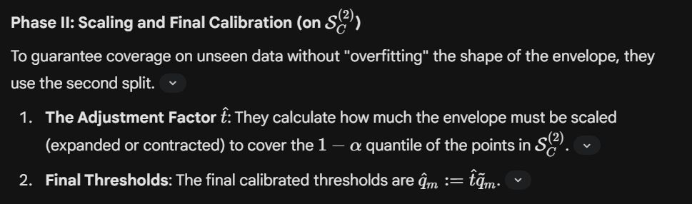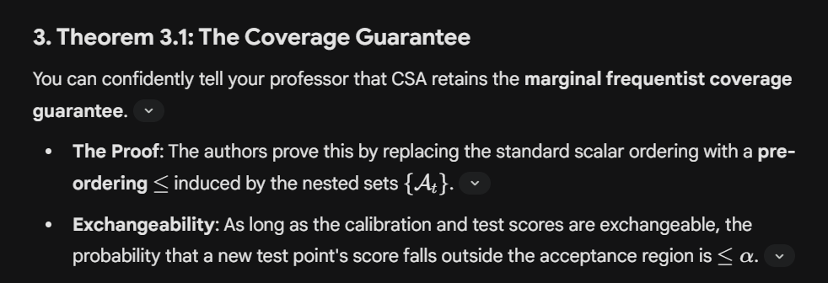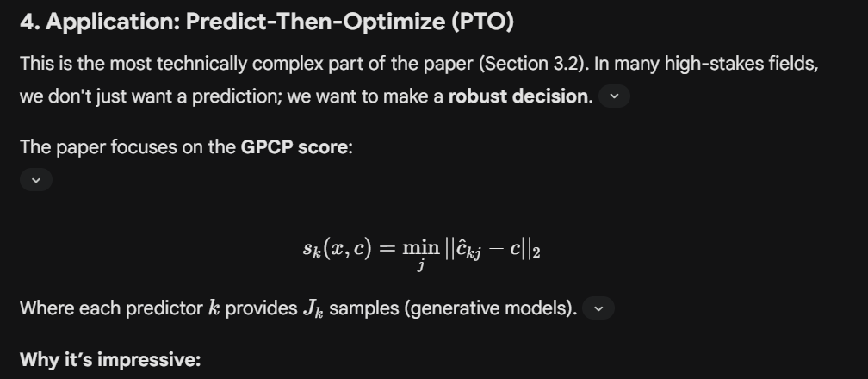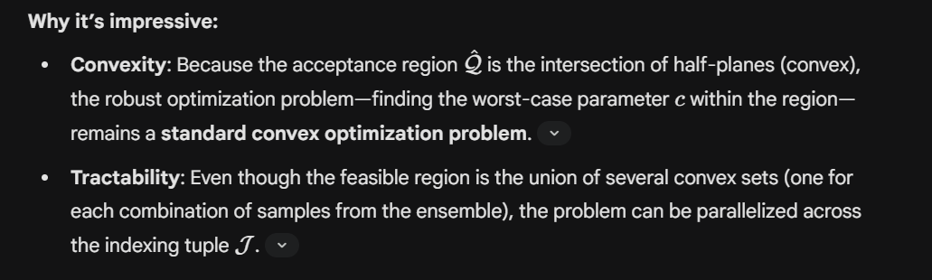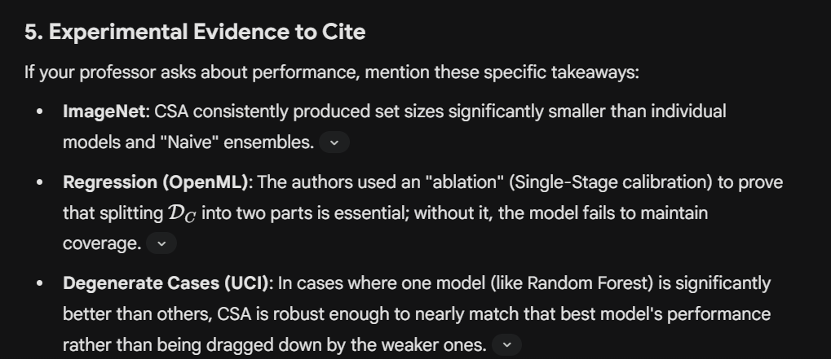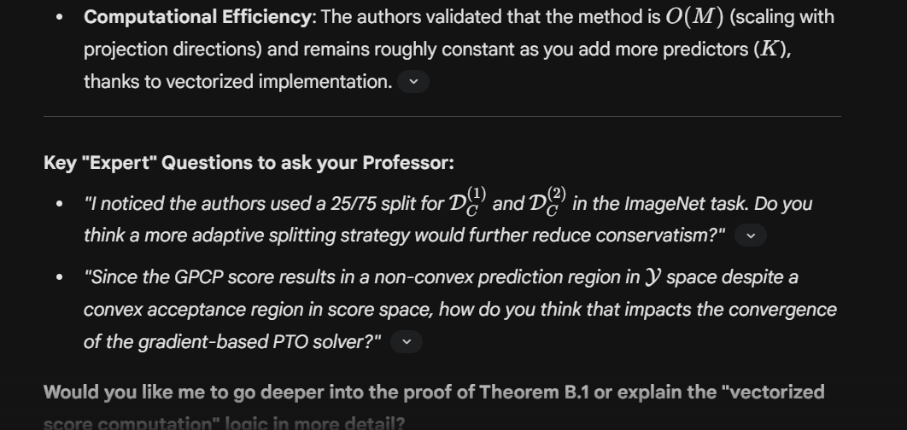

Screenshots
In Section 4, the authors present empirical results to prove that Conformal Score Aggregation (CSA) isn't just theoretically sound, but practically superior to existing methods. Here is a rigorous breakdown of the experiments to help you show your professor that you understand how CSA translates to performance gains.
4.1 ImageNet Classification Tasks
The authors tested CSA on a large-scale image classification task using an ensemble of three distinct deep learning architectures: ResNet-50, VGG-11, and DenseNet-121.
The Setup: They used a standard classification score function based on the cumulative probability of sorted class labels.
The Findings: All methods achieved the required coverage (e.g., 90% for $α$=0.10), but CSA was vastly more efficient.
The "Rigour" Fact: CSA produced average prediction set sizes of 34.006 classes at $α$=0.10, whereas the individual models like ResNet needed 137.004 classes to reach the same coverage guarantee.
Comparison: CSA also beat the closest competitor, VFCP, which required 46.063 classes.

4.2 OpenML Regression Tasks
This experiment tested CSA across five different regression datasets using an ensemble of OLS, LASSO, Random Forest (RF), and XGBoost.
The Scoring: They used a residual-based score function: s(x,y)=|f(x)-y|.
Ablation Study: The authors included a "Single-Stage" version of CSA to prove the necessity of the data-split (D_{C}⁽¹⁾ and D_{C}⁽²⁾).
Key Insight: The Single-Stage approach failed to maintain the required coverage (dropping as low as 0.745 for a target of 0.95), proving that Stage 1 "overfits" the shape of the envelope to the calibration data, thus breaking exchangeability.
Robustness to Degeneracy: On UCI datasets where one model (usually Random Forest) is already optimal, most aggregation methods perform poorly. CSA was robust enough to nearly match the performance of the best single predictor in the ensemble rather than being "pulled down" by the weaker models.

4.3 Robust Traffic Routing (Predict-Then-Optimize)
This is the most complex application, applying CSA to a Manhattan traffic routing problem where traffic is predicted based on precipitation models (STEPS and LDM).
The Goal: Find the optimal routing “w” that minimizes travel time under the worst-case precipitation scenario.
The Metrics: They used the expected suboptimality gap proportion, which measures how "wasteful" or conservative the robust decision is.
The Result: CSA significantly outperformed individual models.
P-Value Evidence: Paired t-tests showed p-values as low as 3.61 × 10^{-4} when comparing CSA to individual models, proving the reduction in suboptimality is statistically significant.

5. Summary of Why CSA Wins
Shared Structure: By looking at the multivariate score space, CSA exploits the fact that if two models are often wrong in the same way, the envelope can be "trimmed" in that direction.
Adaptive Size: Unlike scalar conformal prediction, which often gives fixed-size "intervals," CSA prediction regions change in size across the covariate space X even if the scores don't.
Efficiency: Because of vectorized implementation (detailed in Appendix D), calculating these complex envelopes takes only fractions of a second (e.g., 0.11s for 6 predictors and 10 directions)

Summary
To ensure your professor sees that you have mastered the paper's 21-page complexity, you should frame your discussion around the geometric necessity of Conformal Score Aggregation (CSA) and its computational advantages.

1. The "Score Space" vs. "Output Space" Argument
The critical distinction of CSA is that it performs aggregation in the score space $R^{K}$ rather than the output space Y
- Why it matters: Traditional methods (like Majority Vote) merge prediction regions, which "forgoes the possibility of automatically leveraging shared structure amongst the scores".
- Rigorous explanation: By defining a pre-ordering ($≤$) via an indexed family of nested convex sets {$A_{t}$}, the authors create a data-driven fusion function t(s) that acts as a generalized scalar score.
2. The Two-Stage Calibration Mechanics
Explain why the authors partition the calibration set S_{C} into S_{C}⁽¹⁾ and S_{C}⁽²⁾.
- Stage 1 (S_{C}⁽¹⁾): Used to discover the optimal shape of the quantile envelope.
- Stage 2 (S_{C}⁽²⁾): Used to compute the final adjustment factor $\hat{t}$to ensure $1-α$ coverage guarantee.
- Ablation Proof: In their regression experiments (Table 2), the "Single-Stage" approach failed to achieve sufficient coverage (often dropping below 90% for a 95% target), proving that data splitting is non-negotiable for mathematical validity.
3. PTO: Robustness and Convexity
Discuss the Predict-Then-Optimize (PTO) extension in Section 3.2. This is highly relevant to computational biology pipelines.
- The Constraint: CSA's acceptance region $\hat{Q}$ is an intersection of half-planes, which is always a convex set.
- Optimization: Because the projection directions $u_{m}$are restricted to the positive orthant $R_{+}^{K}$ the inner maximization problem for finding the worst-case parameter c remains a standard convex optimization problem.
- Impact: In the Manhattan traffic task, CSA reduced suboptimality gaps with extreme statistical significance (p-values < ${10}^{-3}$).
4. Technical "Deep-Dive" Questions for Your Professor
Ask these to show you are thinking about the paper's limitations and future work:
- "The authors used a binary search to find the optimal $β$between $\left(α∕M,α\right)$. Do you think a more sophisticated gradient-based approach for tuning directional weights could further shrink the Lebesgue measure of the acceptance region?"*.
- "I noticed that for K>2 predictors, the authors sample directions stochastically using Gaussian draws. In high-dimensional biology data where K might be large, would we see a performance drop-off due to the 'curse of dimensionality' in hypersphere sampling?".
- "While the acceptance region $\hat{Q}$ is always convex, the paper notes the final prediction region in Y might not be. In our lab's work, would non-convex prediction sets pose a significant challenge for downstream interpretation?".
Summary of Performance Statistics
Metric | Individual Models (ResNet/VGG) | CSA (Proposed)
ImageNet Set Size  ($α$ =0.10) | ~136.5 classes | 34.006 classes
Efficiency Scaling | N/A | $\mathcal{O}(M)$ with directions
PTO Suboptimality | Higher | Significantly Lower

Questions
- What do you mean by conformal?
- What is conformity score?
- What is the quantile envelope and what does it show?
- What are the multivariate scores?
- Where do these scores come from and what do they represent?

